|  |  |
| --- | --- |
| wede5020  Small Business Proposal | Name: Boikhantsho Mtolo  Student Number: ST10479540  Module Code: WEDE5020  Subject: Web Development  Group: 2 DISD1 |

Table of Contents

Introduction 2

Website Goals and Objectives’ 3

Website features and Functionality 4

Design and user experience 5

Wireframes to visualise the website’s layout and information hierarchy 6

Technical Requirements 8

Timeline and Milestones: 9

Budget 9

Referencing 10

# Introduction

The small business ‘Boi’S Beauty Space’ is founded by a young lady named Boikhantsho Mtolo.

She started the business in 2025 on the 10th of August. She finds happiness in beauty and so she came to a conclusion to bring it to reality.

A background brief about ‘Boi’S Beauty Space’:

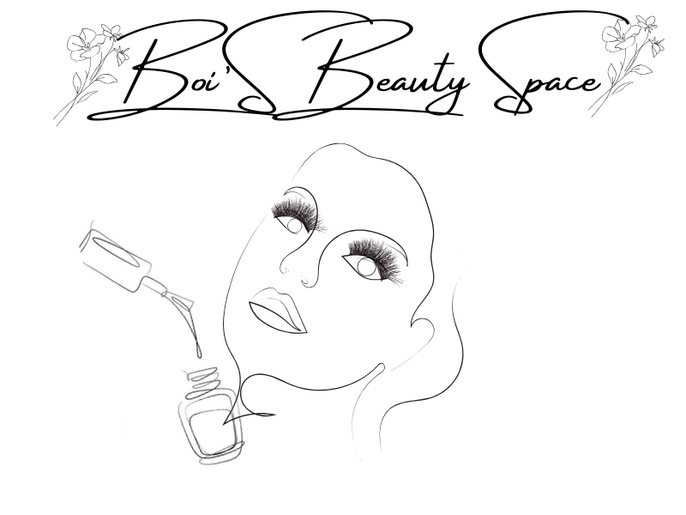

**Boi’S is a small business that invites ladies and men to come and detox as they are treated well throughout their treatment . It offers services such as:**

* **Manicure and Pedicure designs**
* **Lash Extensions**
* **Frontal Installation**
* **Weave Revamp**

**Mission and Vision Statement**

Boi’S is working towards makings brunches across South Africa.

In South Africa there as plenty of small businesses that provide the same services, Boi’S is unique from those businesses because they focus on the wellness of the client they are attending to.

The word ‘Space’ in the business title means that, they provide a safe space for clients to detach themselves from whatever they are going through and bring happiness that will brighten up their week ahead of them.

The **vision** is not clear to date, the purpose of the business is what makes this goal achievable.

Their **target audience** are ladies from age 17-35 and gentlemen from age 21- 35.

# Website Goals and Objectives’

The goals for this website is very detailed:

* The website will showcase the nail designs that were done to date.
* Allow clients to fill in a form to book for their first or next appointment.
* Provide valuable information about the location of the salon as well as share the salon policies.
* The website will also allow clients to give their reviews based on their experience using a KPI.

A Key Performance Indicator (KPI) is a measurable metric used by organizations to evaluate and track their progress toward specific operational or strategic objectives. KPIs help businesses monitor performance, make well-informed decisions, and improve operational efficiency by providing quantifiable evidence of how well goals are being met.

The KPI tools that will be used for this business is the **Customer key performance indicator** and the **Performance measurement** . They will be used to be measure the user performance and interaction.

# Website features and Functionality

This website will consist of 5 pages being:

* Home page

The Home page will be showing pictures if the services the business is providing, there will be limited information on it.

* About Us

This page will provide valuable information about the business and their services and where to find the business’s physical location, further more give a brief background of the business.

* Nails

The Nails page will showcase the designs and prices of the nails that can be done and also give clients a platform to put in their opinions.

* Lashes

The Lashes page will as well showcase the designs and prices of the lashes.

* Contact Us

The Contact Us page will have contact information for those who want to get in touch with the business for any enquiries.

The functionality that will be added is the moving from page to page, using HTML buttons that will be hyperlinked to the web page to allow movement between the pages.

# Design and user experience



Colour Scheme:



Typography: font (Serif)

**HIERARCHY (site map)**

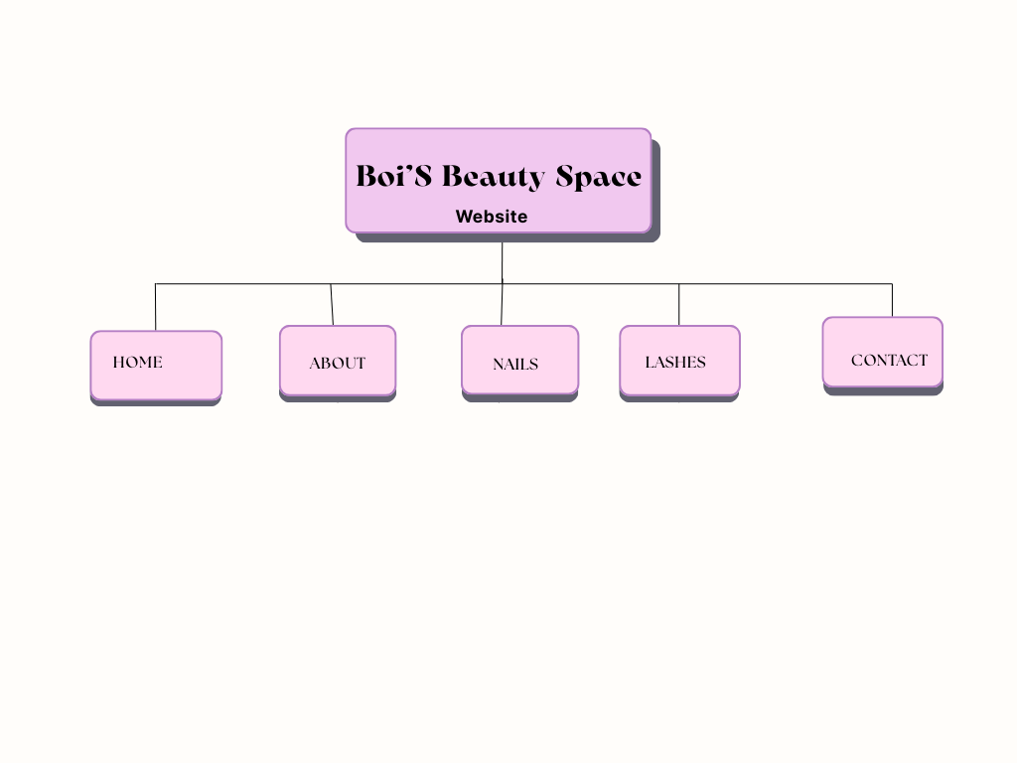

Layout and design and User experience:

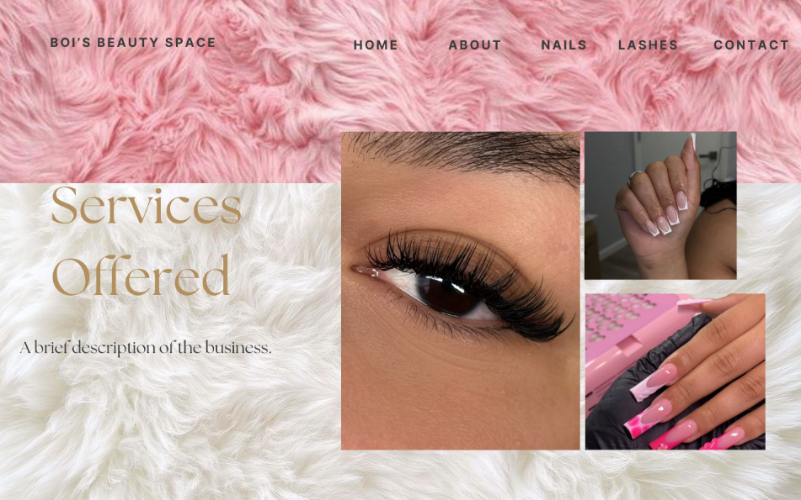

The Layout that will be used is frames to have a realistic effect when using pictures (e.g the fur that is used on the home page wireframe)

The design will include pictures that show the client what to expect when browsing through the website.

The navigation bar will be on the top middle or right of the web page.

# Wireframes to visualise the website’s layout and information hierarchy

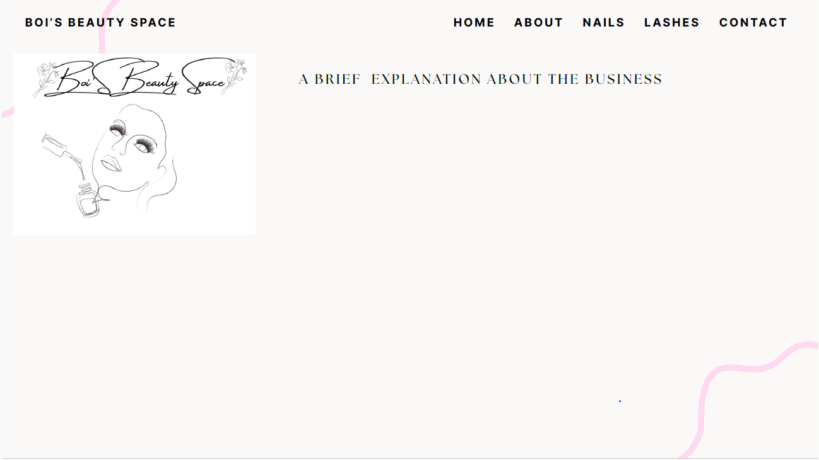

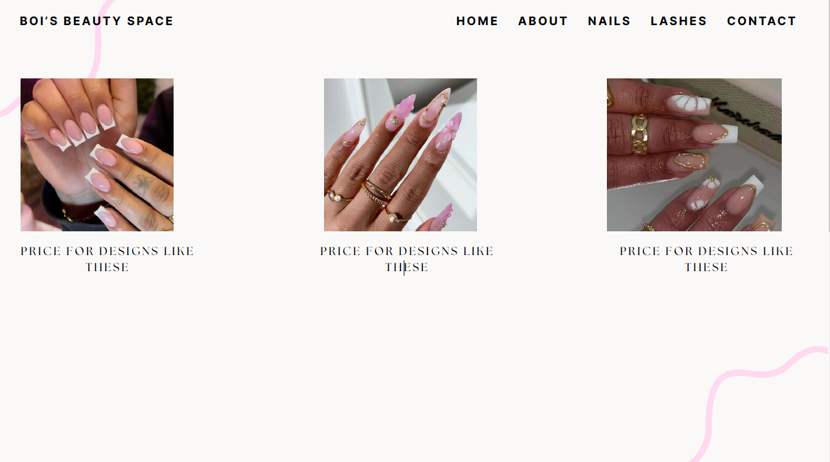

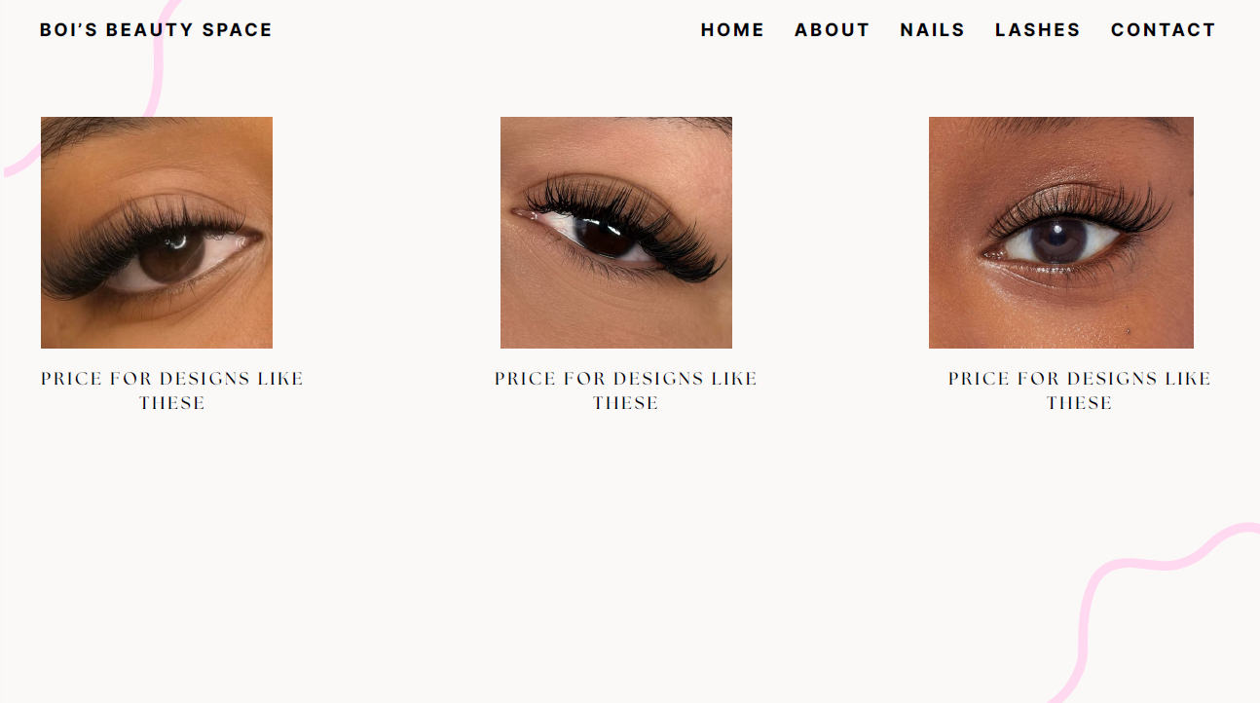

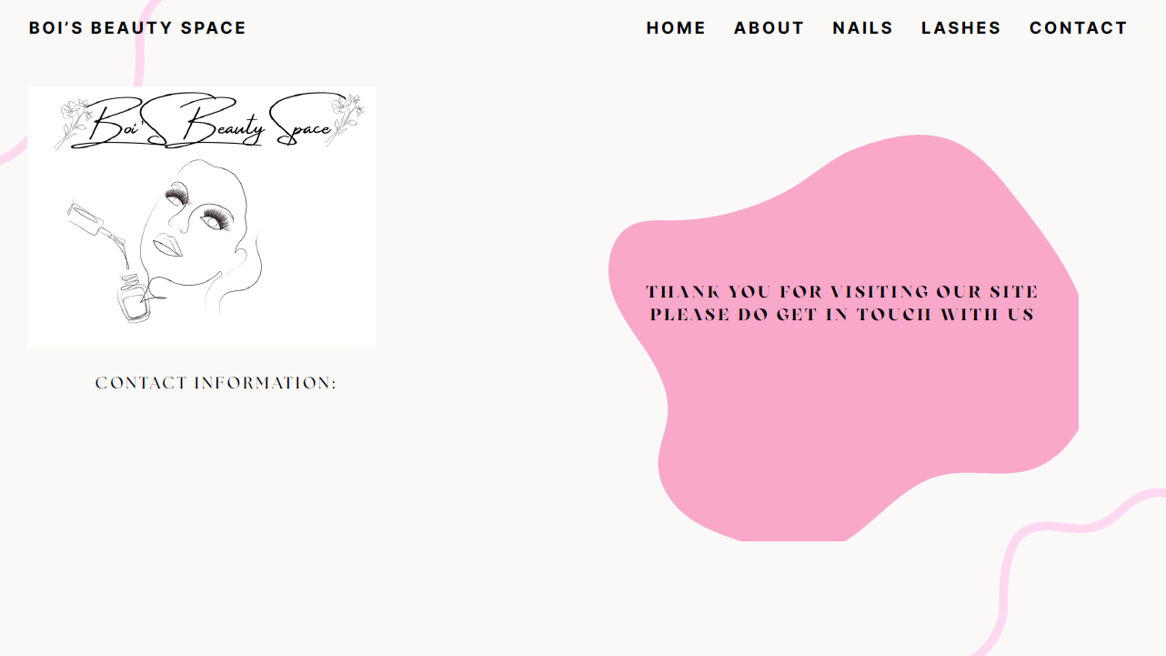

# Technical Requirements

**Hosting company:** Webway.

<https://webway.host/>

**Domain name requirements:www. boisspace.co.za**

* A domain name should be registered.
* IP address, primary and secondary name servers of the registered domain name.
* Date of creation and term of registration.

<https://www.networksolutions.com/help/article/us-domain-name-requirements>

**Programming language:**

The programming languages that will be used are HTML and CSS.

HTML – responsible for the structure of the website.

CSS – responsible for the style of the website.

JavaScript – responsible for the website’s response .

# Timeline and Milestones:

Start date : 19 August 2025

Rough-Draft (Proposal One): 21 August 2025

Research (Proposal One): 21 August 2025

Proposal One : 23 August

Rough-Draft (Proposal Two): 24 August 2025

Research (Proposal Two): 24 August 2025

Proposal Two: 26 August 2026

Website : 26 August 2026

Completion date : 27 August 2025

# Budget

Website hosting: R 300 – R2000 per Month

Marketing: R1500

Maintenance : R 1500

# Referencing

Hosting company

<https://webway.host/>

Domain Requirements

<https://www.networksolutions.com/help/article/us-domain-name-requirements>

Website hosting

<https://hostafrica.co.za/blog/hosting/how-much-is-it-to-host-a-website/#:~:text=Shared%20Hosting%20%E2%80%93%20Affordable%20and%20Accessible,most%20affordable%20kind%20of%20hosting>.